ASSIGNMENT : WORKFLOW
Patient Appointment Automation Suite — Workflow Options Use Case (Lab Record)

Objective
To design and build a complete automation layer in Zoho Creator for the existing "Patient Appointment Booking" application, demonstrating the correct usage of all eight Workflow options available in Zoho Creator — Form Workflows, Schedules, Approvals, Payments, Blueprints, Batch Workflows, Report Workflows, and Functions — so that the appointment lifecycle runs with minimal manual intervention from booking to post-visit follow-up.

Problem Statement
The Appointment_Booking_Form and its supporting pages and reports capture and display data well, but every downstream action currently depends on a human: sending appointment confirmations, reminding patients of upcoming visits, getting a doctor's sign-off before booking a high-risk or special procedure, collecting the consultation fee before the visit, reminding a large batch of patients due for follow-up visits, and recalculating the net payable fee when the insurance coverage or consultation fee changes. This manual dependency does not scale during peak clinic hours, and it introduces delay and inconsistency.
A complete automation layer is therefore built on top of the Appointment_Booking_Form, using every Workflow option Zoho Creator provides, so that routine actions happen automatically, special procedures are routed for a doctor's approval, consultation fees are collected without manual follow-up, and appointment status moves through a controlled, auditable process.

Scope of the Use Case
- Application Name: Patient Appointment & Scheduling Management
- Base Form/Report: Appointment_Booking_Form, Appointment_Booking_Report
- Primary Users: Patients (indirect, via automated communication), Front Desk, Doctors, Clinic
Administrator
- Deliverable: Eight automations, one for each Zoho Creator Workflow option, layered onto the existing appointment process
- Objective of the Automation Suite: Reduce manual effort, enforce a controlled approval and payment process, and ensure timely communication throughout the patient visit lifecycle

Application Structure Used
The application contains the forms shown in the Workflow panel: Appointment Booking (base form),
Department, Doctor Profile, Patient Profile, Payment Record and Visit Summary. The fields of Appointment Booking referred to by the scripts in this record are listed below (link names may be adjusted to match the form).

Field (link name) | Type | Used by
Appointment_ID | Auto number | Confirmation, reminders, function
Patient_Name / Email / Phone_Number | Lookup / Email /  Phone | Form workflow, schedule, function
Doctor, Department | Lookup | Approval, reminder, function
Preferred_Appointment_Date | Date | Daily reminder schedule
Consultation_Fee,  Insurance_Coverage_Percent | Decimal | Net-fee calculation, report workflow
Net_Payable_Fee | Formula / Decimal | Payments workflow
Payment_Status, Transaction_Reference | Dropdown / Single line | Payments workflow
Special_Procedure_Requested | Checkbox | Approval
Status | Dropdown / Blueprint field | Approval, blueprint, function
Reminder_Sent, FollowUp_Required,  FollowUp_Date, FollowUp_Reminder_Sent | Checkbox / Date | Schedule, batch workflow

Workflow Options Used and Their Mapping
The table below maps every Workflow option available in Zoho Creator to a specific automation built around the Appointment_Booking_Form.
Workflow  Option | Workflow Name | Purpose | Trigger / Frequency
Form Workflows | On_Appointment_Sub mit_Workflow | Sends an instant confirmation email to the patient with their Appointment ID  and notifies the front desk of the new  booking | Triggered instantly on  Add (form submission) of Appointment_Booking  _Form
Schedules | Daily_Appointment_R eminder_Schedule | Runs once a day to identify patients with an appointment scheduled for the  next day and sends a reminder with the time and doctor's name | Scheduled to run daily at  6:00 PM, all year round
Approvals | Special_Procedure_Ap proval | Routes any appointment requesting a special or high-risk procedure to the  concerned doctor for approval before  the slot is confirmed | Triggered on Add/Edit whenever the  appointment is flagged  for a Special_Procedure_  Requested
Payments | Consultation_Fee_Pay ment_Workflow | Generates a payment link for the computed Net_Payable_Fee, redirects  the patient to the payment gateway, and updates Payment_Status automatically on success or failure | Triggered immediately after form submission,  before the confirmation email is sent
Blueprints | Appointment_Lifecycl e_Blueprint | Defines and enforces the full patient-visit lifecycle as a controlled  sequence of stages with role-based transition permissions | Applied to every record in Appointment_Booking _Report; stages:  Requested → Confirmed  → Checked-In →  Consulted → Cancelled
Batch Workflows | Bulk_FollowUp_Remi nder_Batch | Identifies all patients whose doctor recommended a follow-up visit within  a specific window and sends them a  reminder to rebook, processed in  controlled batches | Triggered automatically every night at 9:00 PM,  processing records in batches of 150
Report Workflows | OnEdit_Recalculate_N etFee_Workflow | Recalculates the Net_Payable_Fee field whenever front-desk staff  manually edit the Consultation Fee or  Insurance Coverage Percent directly from the report | Triggered on Edit of any record within the Appoint ment_Booking_Report
Functions | Generate_VisitSummar y_Function | A reusable custom function that generates a visit summary/prescription  PDF after consultation and emails it to the patient; callable from a button, a schedule, or another workflow | Invoked automatically when an appointment's Status changes to  'Consulted', and also callable manually via a  'Resend Visit Summary' button

Automation Details and Configuration (Workflow-wise)
6.1 On_Appointment_Submit_Workflow (Form Workflow)
Form | Event | Action type | Governance rule
Appointment_Booking  _Form | Create → On  Success | Send Mail + Deluge script | Fails gracefully and logs an error if the contact number is invalid; never blocks  the booking
Fires the moment a new record is added. It sends the patient a confirmation containing the Appointment ID and visit details, and notifies the front desk to prepare the patient file.
Steps: Workflow → Form workflows → New Workflow → select Appointment Booking → Name:
On_Appointment_Submit_Workflow → Trigger: Created → On success → Add a Deluge script action.
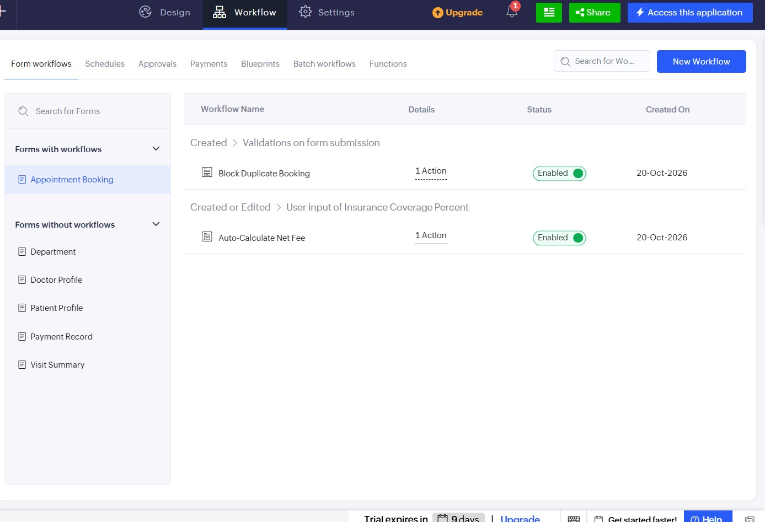
Fig. 1: Workflow → Form workflows panel for the Appointment Booking form (Block Duplicate Booking and Auto-Calculate Net Fee workflows enabled)
6.2 Daily_Appointment_Reminder_Schedule (Schedule)
Form | Frequency | Time | Governance rule
Appointment_Booking  _Form | Daily, no end date (all year) | 6:00 PM | Only one reminder per appointment  (Reminder_Sent flag)
Runs automatically every evening without manual trigger, querying all records whose Preferred
Appointment Date equals tomorrow's date. The reminder includes the doctor's name, department, and pre-visit instructions.
Steps: Workflow → Schedules → New Schedule → Form: Appointment Booking → Frequency:
Daily → Time: 06:00 PM → Ends: Never → Deluge script.
6.3 Special_Procedure_Approval (Approval)
Form | Trigger | Approver | Governance rule
Appointment_Booking  _Form | Add/Edit when Special_Pro cedure_Requested = true | On-call doctor of the department | Fallback approver:  Department Head, if the on-call doctor is unavailable
Only appointments explicitly flagged for a special or high-risk procedure enter this process; routine consultations bypass it. The record's Status stays at Pending Doctor Approval until the doctor approves or reschedules it from the approval inbox.
Steps: Workflow → Approvals → New Approval → Form: Appointment Booking → Criteria: Special_Procedure_Requested is true → Approver: on-call doctor (Department → On_Call_Doctor), with Department Head as fallback → Actions below.
6.4 Consultation_Fee_Payment_Workflow (Payments)
Form | Amount field | Trigger | Governance rule
Appointment_Booking  _Form | Net_Payable_Fee | Immediately after submission, before the confirmation e-mail | Gateway status-check callback retried up to 3 times before the transaction is flagged as failed
Integrates a payment gateway connector (e.g. Razorpay / PayU) configured in Zoho Creator to generate a secure payment link based on the Net_Payable_Fee formula field. On success it updates Payment_Status to 'Paid' and stores the transaction reference; on failure it flags the record for front-desk follow-up at check-in.
Steps: Workflow → Payments → New Payment Workflow → Form: Appointment Booking →
Gateway: configured connector → Amount: Net_Payable_Fee → Customer: Patient_Name, Email, Phone_Number → set Success / Failure actions.
6.5 Appointment_Lifecycle_Blueprint (Blueprint)
Defines the full patient-visit lifecycle for every record of Appointment_Booking_Report with role-restricted transitions. Every transition has a mandatory Comment field, so an auditable reason is logged for each status change; the Blueprint view gives the administrator a visual trail of when and by whom each appointment moved between stages.
Appointment_Lifecycle_Blueprint - stage diagram with transition permissions
Requested
Confirmed
Checked-In
Consulted
Front Desk
Desk / Kiosk
Doctor
Cancelled
Cancel: Front Desk / Administrator
(
comment mandatory on every transition
)
Transition | From → To | Allowed role | During transition
Confirm | Requested → Confirmed | Front Desk, Administrator | Mandatory comment
Check In | Confirmed → Checked-In | Front Desk, Kiosk user | Mandatory comment
Consult | Checked-In → Consulted | Doctor only | Mandatory comment;  after-action calls Generate_Visit  Summary_Function
Cancel | Requested / Confirmed / Checked-In → Cancelled | Front Desk, Administrator | Mandatory comment  (cancellation reason)
Steps: Workflow → Blueprints → New Blueprint → Form: Appointment Booking → Field: Status → add stages Requested, Confirmed, Checked-In, Consulted, Cancelled → define each transition, set the allowed role, add a mandatory Comment field in the During section, and enable the blueprint.
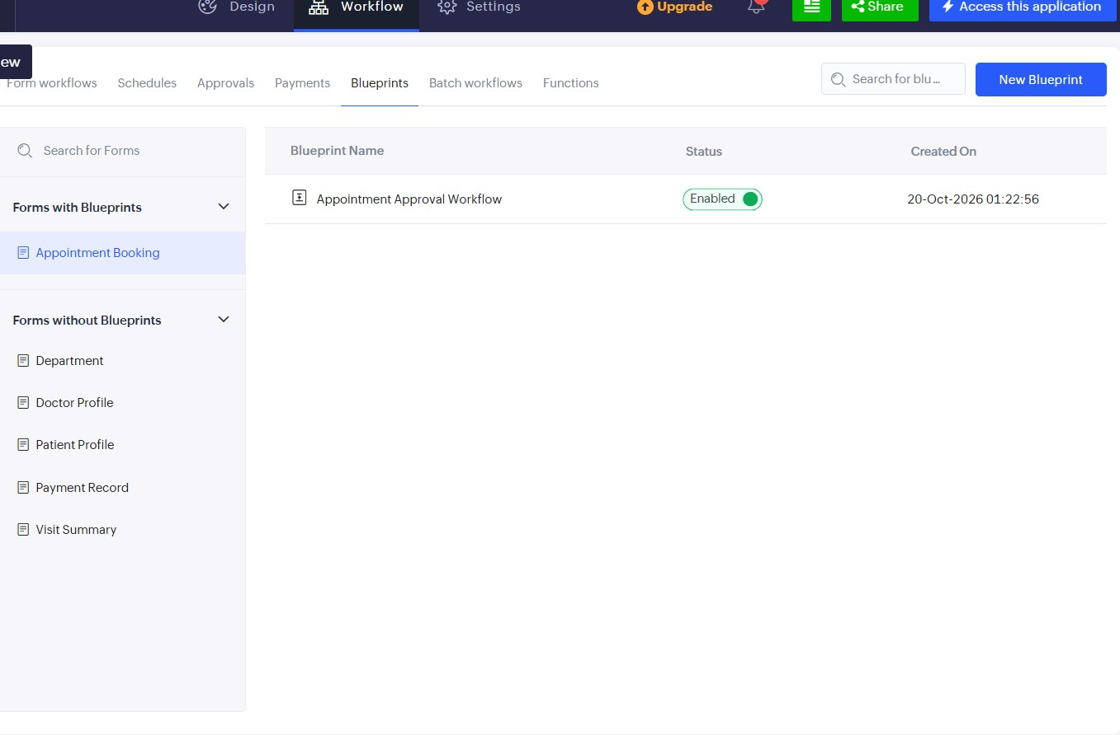
Fig. 2: Workflow → Blueprints panel for the Appointment Booking form with the blueprint enabled
6.6 Bulk_FollowUp_Reminder_Batch (Batch Workflow)
Form | Schedule | Batch size | Governance rule
Appointment_Booking  _Form | Every night, 9:00 PM | 150 records  (configurable) | Processes records in batches to avoid workflow-engine timeouts
Identifies every patient whose recommended follow-up window is approaching and prompts them to book their next visit. Records are processed in batches rather than all at once, which prevents timeouts on a large patient list.
Steps: Workflow → Batch workflows → New Batch Workflow → Form: Appointment Booking →
Criteria: FollowUp_Required is true and FollowUp_Date within the next 7 days and FollowUp_Reminder_Sent is false → Batch size: 150 → Schedule: Daily 9:00 PM → Deluge script.
6.7 OnEdit_Recalculate_NetFee_Workflow (Report Workflow)
Report | Event | Restricted to | Governance rule
Appointment_Booking_  Report | On Edit (inline edit in report grid) | Consultation_Fee, Insura nce_Coverage_Percent | Fires only when these two fields change
Keeps Net_Payable_Fee accurate when front-desk staff manually change the consultation fee or insurance coverage directly in the report grid, without requiring a full form resubmission, and prevents inconsistent billing caused by manual overrides.
6.8 Generate_VisitSummary_Function (Function)
Written once as a reusable Deluge function and called from multiple places: automatically when a visit's Status changes to Consulted, manually via a 'Resend Visit Summary' button, or from a batch that reissues summaries for insurance claims. Centralising the logic avoids duplicating visit-summary code across workflows. It includes input validation so it fails safely if the record has no Patient Name or Doctor.
Steps: Workflow → Functions → New Function → Name: Generate_VisitSummary_Function → Argument: appointmentID (int) → Return type: string.
Evidence of reuse - the same function called from different workflow types:
# | Workflow type | Where it is called | Call
1 | Form Workflow | Appointment_Booking_Form → Edited →  On success, criteria Status == "Consulted" (also as the Consulted-transition after-action in the Blueprint) | Calls Generate_VisitSummary_F unction with the appointment ID
2 | Report Workflow  (custom action button) | Appointment_Booking_Report → button  'Resend Visit Summary' | Calls Generate_VisitSummary_F unction with the appointment ID
3 | Batch Workflow  (optional) | Re-issue summaries for insurance-claim cases | Calls Generate_VisitSummary_F unction for each record in the batch

Sample Confirmation Message and Payment Link (End-to-End)
On submitting the Appointment_Booking_Form, the Payments workflow generates a payment link for the Net_Payable_Fee and, once the patient pays, the confirmation e-mail below is sent by On_Appointment_Submit_Workflow. The text below shows the message format; values in angle brackets are filled in by the workflow.
Subject : Appointment Confirmation - <Appointment_ID>
Dear <Patient_Name>, Your appointment has been booked successfully.
Appointment ID : <Appointment_ID>
Doctor : <Doctor>
Department : <Department>
Date : <Preferred_Appointment_Date>
Consultation fee payable (after insurance) : Rs. <Net_Payable_Fee>
Pay your consultation fee securely using the link below:
<payment link generated by the Payments workflow>
Payment_Status is updated to "Paid" automatically after payment.
Thank you. - Clinic Front Desk

Configuration & Governance Rules
Workflow | Governance rule configured
Form Workflow | Fails gracefully and logs an error if the patient's contact number is invalid, rather than blocking the booking
Schedule | Sends only one reminder per appointment (Reminder_Sent flag)
Workflow | Governance rule configured
Approval | Department's on-call doctor as approver, with fallback to the department head if unavailable
Payments | Gateway status-check callback retried up to 3 times before the transaction is flagged as failed
Blueprint | Every stage transition requires a mandatory comment, giving an auditable reason for each status change
Batch Workflow | Batch size configurable (default 150 records) to balance speed against system load
Report Workflow | Fires only when Consultation Fee or Insurance Coverage Percent changes
Function | Input validation: fails safely if the record has no Patient Name or Doctor

Workflow Summary (End-to-End)
- Step 1: A patient submits the Appointment_Booking_Form, triggering
On_Appointment_Submit_Workflow (Form Workflow), which sends a confirmation.
- Step 2: Consultation_Fee_Payment_Workflow (Payments) generates a payment link and updates Payment_Status once the patient pays.
- Step 3: If a special procedure is requested, Special_Procedure_Approval (Approvals) routes it to the concerned doctor before the slot is confirmed.
- Step 4: The record moves through Appointment_Lifecycle_Blueprint (Blueprints) stages as staff confirm, check in and consult the patient, each transition logged with a comment.
- Step 5: Each evening, Daily_Appointment_Reminder_Schedule (Schedules) messages patients with an appointment the next day.
- Step 6: If front-desk staff adjust the fee or insurance coverage in the report, OnEdit_Recalculate_NetFee_Workflow (Report Workflows) keeps the net payable fee accurate.
- Step 7: The moment a visit is marked Consulted, a workflow calls
Generate_VisitSummary_Function (Functions); staff can also resend it using a button.
- Step 8: Every night, Bulk_FollowUp_Reminder_Batch (Batch Workflows) reminds patients whose follow-up window is approaching, processed in batches.

Learning Outcomes Achieved
- Understood the purpose and correct use case of each Workflow option in Zoho Creator.
- Learned the difference between event-driven automation (Form and Report Workflows) and time-driven automation (Schedules).
- Designed a controlled, auditable process using Blueprints alongside a human checkpoint using Approvals.
- Understood how Batch Workflows prevent performance issues when processing large data volumes.
- Wrote reusable logic once as a Function and invoked it from different workflow types.
- Integrated an external payment gateway through a Payments workflow while keeping the patient experience smooth.
Result: All eight Zoho Creator workflow options were configured on the Appointment Booking application, automating the appointment lifecycle from booking to post-visit follow-up.

